Setting up the “Submit a Receipt” Skill for an AtBot Enterprise Demo

# Set up your bot

If you haven’t already, be sure to create and configure an AtBot by following steps 1 through 3 in the [Enterprise Jump Start Guide](https://tinyurl.com/AtBotJumpStart). This document is your go-to guide for getting your enterprise AtBots up and running and you should keep it handy whenever you’re building out AtBots.

# Import the LUIS App

The LUIS App provides the natural language processing for the demo. It will be used to kick off the Flow and it will also take in the expense item, the cost, and the date based on the user’s input.

1. Download the LUIS App (JSON file) stored in the [demo resources folder](https://mobileentree-my.sharepoint.com/:f:/g/personal/matt_wade_h3s_co/Ep1YuExOpwpDmbu34cNxCJoByFQ9UNbk2OwrdugJAz3bFg?e=UPz1yq).
2. Open luis.ai and sign in.
3. In the My Apps listing, click **Import new app** > **Choose app file (JSON format)…** > **upload** the file downloaded in Step 1 of this section > **Train** > **Publish** (to production).
4. Click your name in the top-right corner > **Settings**.
5. Copy your **Authoring Key**. Place it somewhere for later (a text file, a Word document, a task in Outlook, etc.).

# Create the LUIS Intent Vector

The LUIS Intent Vector adds on the LUIS intent by making certain input required. If some input wasn’t provided, the IV will then request the input from the user.

1. Open the AtBot Admin Portal at admin.atbot.io.
2. Click **AI Integrations** > **LUIS Intent Vectors** > **Create Intent Vector**.
3. Enter the LUIS App Region.
4. Enter the copied **Authoring Key** from step B.5.
5. Select the LUIS App (the default name of the provided App is “Submit a Receipt”).
6. Select the LUIS Intent (the default name of the provided Intent is “Submit an expense”).
7. Click **Create Intent Vector**.
8. Add each of the **Available Entities** as **Configured Entities** by pressing the plus sign next to the entity in the **Available Entities** column.
9. Configure the entities to look like the LUIS Intent Vector file in the [demo resources folder](https://mobileentree-my.sharepoint.com/:f:/g/personal/matt_wade_h3s_co/Ep1YuExOpwpDmbu34cNxCJoByFQ9UNbk2OwrdugJAz3bFg?e=UPz1yq).
10. Click **Update Vector**.

Your Intent Vector will now be available to choose as an intent in the trigger in your Flow.

# Import the Flow

The Flow is the stepped workflow that runs once LUIS triggers it. The Flow will not run until all required input is supplied via the Intent Vector (section C above). As built, the Flow requires a SharePoint library to upload a file to.

First you need to create the SharePoint library. Generally, a modern SharePoint Online site works best; it doesn’t matter whether you use a Team or Communication Site. If you’re creating from scratch, use a Team site and set the members as anyone that will be using the bot or demoing it.

Once you create your site:

1. Open you SharePoint site.
2. Click the **gear** in the top right corner > **Add an app** > **Document Library** > **[Give it a name]** > **Create** > **Open your library**.
3. Click **Add column** > **Date and Time** > Name it **Date**.
4. Click **Add column** > **Currency** > Name it **Cost** (choose the appropriate currency).
5. Order the columns left-to-right how you prefer.

Now you need to import your Flow:

1. Download the Flow (ZIP file) stored in the [demo resources folder](https://mobileentree-my.sharepoint.com/:f:/g/personal/matt_wade_h3s_co/Ep1YuExOpwpDmbu34cNxCJoByFQ9UNbk2OwrdugJAz3bFg?e=UPz1yq).
2. Open flow.microsoft.com and sign in.
3. Click **My Flows** > **Import** > **Upload** > Choose your file. Update each of the Resource Types as listed below. Once they are selected, click **Import**. For each Resource Type:
   1. Set *Flow* to “Create as new”.
   2. Set *AtBot Logic Connection* to “Select during import”. If there is no connection listed, click **Create new** > **New connection** > Find **AtBot Logic** and **Add (plus)**.Go back to the Flow tab > **Select during import** > choose your newly created connection > **Save**.
   3. Set *SharePoint Connection* to “Select during import”. If there is no connection listed, click **Create new** > **New connection** > Find **SharePoint** and **Add (plus)**.Go back to the Flow tab > **Select during import** > choose your newly created connection > **Save**.
   4. Set *Office 365 Users Connection* to “Select during import”. If there is no connection listed, click **Create new** > **New connection** > Find **Office 365 Users** and **Add (plus)**.Go back to the Flow tab > **Select during import** > choose your newly created connection > **Save**.
4. Open the imported Flow: **My Flows** > **[Flow name]**.
5. Click the trigger. Ensure **Bot Trigger Type** is set to **Shared** and select the LUIS Intent Vector from earlier in that field.
6. In the **Create file: upload receipt** step, update the Site Address to the site you’re using from above. Update the Folder path to the Library you created. The File Name should be set (using a Flow expression to concatenate the date and time and the user name to create a unique name.
7. In the **Update file properties: apply metadata to receipt** step, update the **Site Address** to the site you’re using and the **Library Name** to the library you created. If necessary, updated the Title, Date, and Cost using the LUIS entities and your cost variable, as shown below:  
   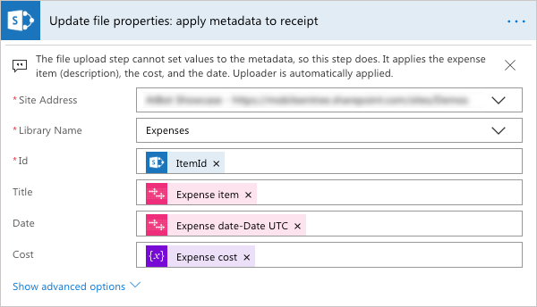
8. In the **Send reply: Confirmation** step, update the URL listed in the HTML to point to your SharePoint Library.

Your Flow, which is now connected to a LUIS intent, is considered an AtBot Skill. We will use “Skill” from now on to represent the combination of the two.

# Configure your AtBot

1. Open the AtBot Admin Portal at admin.atbot.io.
2. If your bot doesn’t have an assigned category, [create a category](https://admin.atbot.io/Docs/Categories) and [assign it to your bot](https://admin.atbot.io/Docs/EnterpriseBots/BasicConfiguration).
3. [Add your new Skill](https://admin.atbot.io/Docs/Skills) into your category.

# Next steps

1. Add a QnA Maker knowledge base utilizing Chit-Chat for some basic small talk ability by your bot. It makes the experience more natural and entices users to trust the bot more if you’re letting others try it out. Review step 6 in the [Enterprise Jump Start Guide](https://tinyurl.com/AtBotJumpStart) for more info.
2. Ensure you’ve provided licenses for testers/demo-ers and add the bot to Microsoft Teams. All steps can be found in the [Enterprise Jump Start Guide](https://tinyurl.com/AtBotJumpStart).